Your course requires the purchase of a lab kit. It contains all of the materials you will need to perform the labs for this course. Please order in advance of the course start date!.

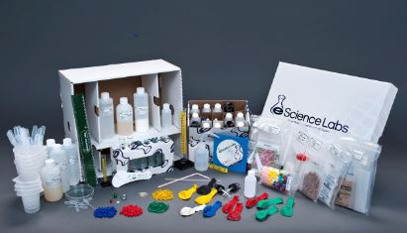

Ordering Your Kit: KIT5246

Your lab kit is available directly from the eScience Labs website. They will ship it directly to you.
To place your order follow the steps outlined below:
- Go to www.esciencelabs.com
- Go to the top right corner and register a new account (if you do not have one already)
- Once logged in, click on the “Have Code?” button on the upper right side of the page
- Enter your SKU # (KIT5246) and proceed to check out

Processing Timeline:

Please allow up to 3-5 business days to process your order and an additional 3-5 business days for delivery. eScience Labs ships all lab kits through standard UPS Ground. Please call 1-888-ESL-KITS for more information.

Student questions:
Please let students know to contact us if they have any questions about the kits at www.eScienceLabs.com/Support. Then Click on “Student” button. This is the fastest way for students to get help.
We can also be reached over the phone (888-375-5487) Monday through Friday, 8am – 5pm Mountain Standard time.

eScience Labs Return Policy
- These science kits are warranted only to contain their stated list of equipment and supplies.
- Only fully intact and resalable products returned within 30 days of receipt qualify for a refund.
- Student must contact eScience Labs, Inc. in advance to request a Return Merchandise Authorization and shipping instructions.
- Kits returned without a Return Merchandise Authorization will be refused by eScience Labs.
- Authorization of refund will be completed within 3-5 days of receiving the returned kit.
- A restocking fee equal to 10% of the product price for inspecting and restocking and any return shipping costs will be deducted from any refund.

