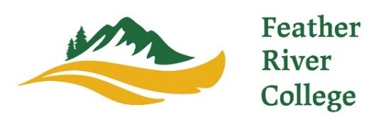
570 Golden Eagle Avenue, Quincy, California 95971
530-283-0202 info@frc.edu www.frc.edu

Feather River College Receives Final State Approval for New Ecosystem Restoration & Applied Fire Management Bachelor’s Degree

Quincy, CA - Feather River College (FRC) announces approval of the Bachelor’s Degree in Ecosystem Restoration and Applied Fire Management from the California Community College Board of Governors. This important approval allows final development of a new applied bachelor’s degree intended to serve residents of Northern California in forest management techniques for the prevention of future wildfires, as well as reforestation and riparian restoration from recent catastrophic events in the Northern Sierra. FRC is excited to receive the final state approval for the degree that brings together many local, regional, state, and private partners with a goal to provide a trained workforce skilled in wildfire prevention techniques, along with watershed and forest restoration practices.

California State Senator, Brian Dahle, noted, "We have learned from hard experience that Northern California's forests need much better management. Accomplishing that work will take well-trained people. I appreciate Feather River College's leadership toward building this vital workforce for the North State."

Feather River College is appreciative for the support of statewide leaders and industry employers in approving this essential degree. Environmental Studies Program Co-Coordinator, Dana Flett, commented, “The faculty at FRC are thrilled to learn about the decision to approve the bachelor's degree program in Ecosystem Restoration and Applied Fire Management. We are incredibly grateful for the vocal support from our partners and community throughout this process and are excited to welcome our first cohort of students! Most importantly, we look forward to working together towards making a meaningful impact on the resilience of our beloved Sierra Nevada ecosystems.”

Michael Hall, the District Manager of Feather River Resource Conservation District, has been instrumental in supporting the degree. He states, "Our organization provides a wide range of ecological restoration services to the upper Feather River watershed. One of our biggest challenges is finding employees with a diverse skill set to address the problems posed from the current wildfire crisis. Feather River College is uniquely situated in a region that has experienced numerous high severity wildfires in recent history. Our work is predominantly tied to dealing with both the fire recovery and reforestation elements, as well as the preventative work that goes into preserving the remaining unburned landscape. A local program with curriculum directly related to this will benefit not only our District, but all Californians. In order to create a robust pipeline for a motivated and qualified workforce we need to invest in the training and education for the next generation of land managers."

While serving its million-acre classroom located throughout the Sierra Nevada ecosystem, Feather River College graduates from this new bachelor’s degree will learn to restore and reforest some of the areas destroyed in Northern California over the past decade. A California State University professor commented on the degree application, “Feather River College is appropriately located in the heart of the northern Sierra, which is ground zero for where this type of restoration work is most desperately needed.” The degree combines unique skills in management of the Sierra ecosystems, federal NWCG certifications required to use prescribed fire to reduce wildland fuels and mitigate future risks, restoring riparian areas, reforesting burned landscapes, and striving to prioritize indigenous perspectives in sustainable land management.

There is an urgent need for a skilled wildfire restoration workforce. Colleagues from Chico State University, Sierra Pacific Industries, CAL FIRE, the US Forest Service, Sierra Institute, Plumas Corp, Feather River Resource Conservation District, Plumas Fire Safe Council, and many others have collaborated and provided essential input to identify the skills and knowledge that will be incorporated into the new bachelor’s degree. In a letter of support for the degree application, a CAL FIRE training supervisor commented, “This degree represents a first-of-its-kind effort to offer students an educational toolkit for the State’s effort to increase the pace and scale of prescribed fire and forest restoration, as articulated by the Governor and the Wildfire and Forest Resilience Task Force.” The bachelor’s degree is one component of the FRC Environmental Studies Department that also offers associate degrees and certificates of specialization in fields such as forestry, fire and fuels management, environmental sciences, and fish hatchery management.

“Graduates will focus on the unique Sierra Nevada ecosystem, its watershed restoration, and learn how to proactively manage forests with prescribed fire and other practices,” stated Dr. Kevin Trutna, Feather River College Superintendent/President. The majority of students surveyed indicated they were not likely to leave the area to earn a bachelor’s degree, so this degree provides a unique opportunity for them to gain additional education and training to be part of the solution to our ongoing wildland fire issues. Dr. Trutna added, “This unserved population is a perfect match to help counteract the catastrophic fire impact we have encountered recently. FRC is very excited to continue our work with the UC, CSU, federal, state, and local employers as the approved degree is one effort to protect and restore natural resources in Northern California.”

Feather River College offers a variety of unique degrees and certificates that feature hands-on learning components. The campus is home to the million-acre classroom that provides intimate access for its students and faculty. Based in the heart of the northern Sierra Nevada mountain range, FRC is continuing to pioneer programs and certificates, as is evident with the recent approval of its second bachelor’s degree offered through the rural yet robust College. For more information on the variety of programs and offerings at Feather River College, please visit its website at frc.edu.

A prescribed burn is underway at the Feather River College campus, led by the Environmental Studies department, to help make our campus forests more resistant to wildfires.

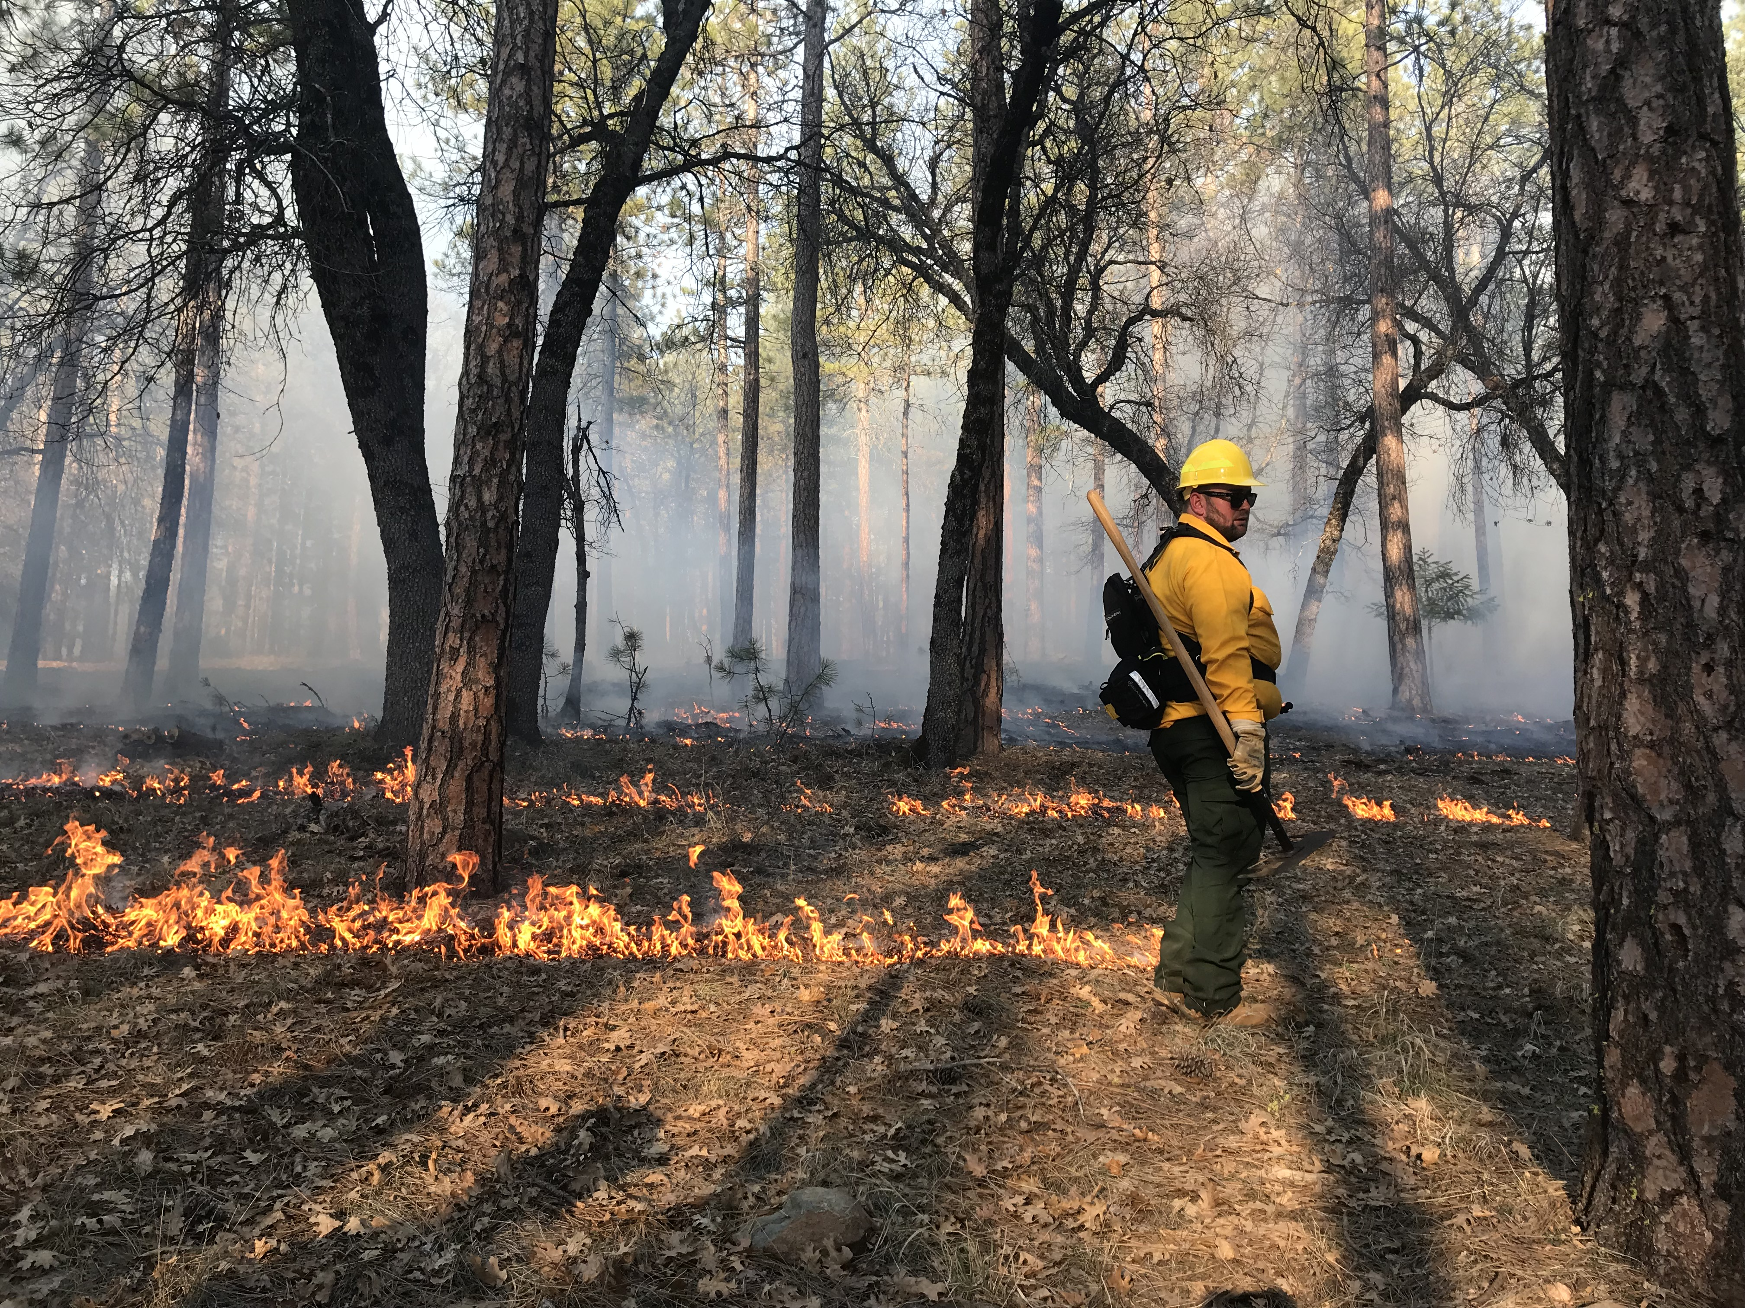
Alex Saunders, FRC graduate, participates along with classmates and faculty in a TREX (prescribed fire-training exchange) event held on the FRC campus

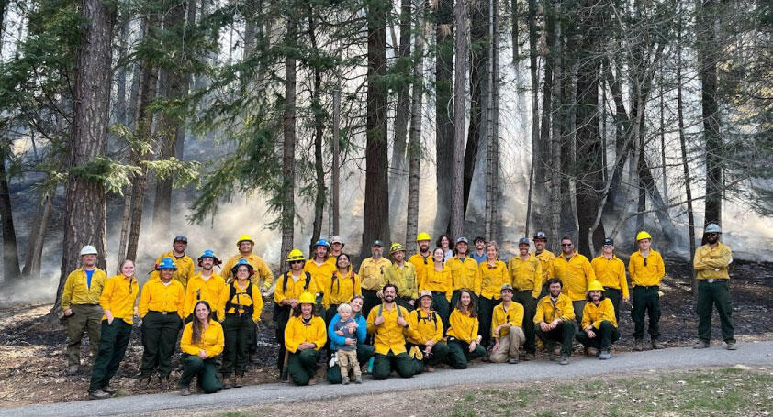
Chico State students, CAL FIRE, and state and local partners assisting in a prescribed burn at the FRC campus

