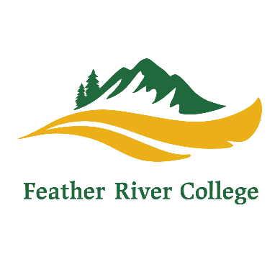
570 Golden Eagle Avenue, Quincy, California 95971
♦530-283-0202
♦info@frc.edu
♦www.frc.edu

To: Students interested in the Licensed Vocational Nursing (LVN) Program from Feather River Community College.
Feather River College will be accepting applications for admission into the 2017 2019 LVN for the Quincy Campus in Quincy, California beginning January 1, 2017, through March 31, 2017. The LVN program is a part-time program, two days per week. The days may vary each semester and will include an eight week clinical in the Valley each summer. For financial assistance contact the FRC Financial Aid office at (530) 283-0202 ext 218/283.
The FRC LVN Program is competitive. There are spots for 30 students for each cohort. The criterion for selection includes completion of the following and review of the associated documentation to determine LVN applicant acceptance.
- FRC Vocational Nursing Program Application for Enrollment
- High School Transcript or copy of HS Diploma or GED Certificate
- College transcripts from colleges attended
- Three letters of recommendation:
    - Previous/current employer
    - Community leader/instructor commenting on your qualities that would make you an asset to the nursing profession.
    - Personal Reference
- Personal Qualifications Statement
- LVN Prerequisites:
BIOL 110 – Human Anatomy/equivalent
BIOL 112 - Human Physiology/equivalent
FACS 170 – Intro to Nutrition/equivalent
NURS 100 – Nurse Aide Course /CNA Certification
NUR 111-Medical dosage Calculations
It is highly recommended that the student take a medical terminology class prior to enrolling in the program.
Transfer credit will be given for prerequisite course work with a grade of C or better. An active Certification for Nursing Assistant is acceptable if not taken at a community college. Certified Medical Assistants may also register Request the original transcripts for high school and college be sent to the Admissions and Records office at FRC, 570 Golden Eagle Avenue, Quincy, CA 95971 Allow at least four weeks for the transcripts to be sent to FRC..
Upon acceptance to the program you will be asked to submit a history and physical, evidence of immunizations and TB testing, and current BLS. Please send applications to:
Judy Mahan, RN, MS or email the packet to jmahan@frc.edu
Feather River College
570 Golden Eagle Ave
Quincy, Ca., 95971 530-283-0202 ext 235

