Academic Program Link to College Mission

Feather River College provides high-quality, comprehensive student learning and education and workforce preparation in a small college environment. The College provides general education, Associate’s Degrees, transfer programs, and life-long learning for a diverse student population. The College serves as a community, cultural, and economic leader encompassing all communities that lie within the District and embraces the opportunities afforded by its natural setting.

Social Science Program Review

A. Staffing

- What is the full- to part-time ratio of faculty within the program? (Determine the ratio by counting up the number of sections taught by full-time faculty and the number of sections taught by part-time faculty in the most recent semester for which the data is available).

For classes taught online and on-campus (i.e. excluding ISP and CE), the ratio for the Spring 2012 semester was 1.9 to 1 (FT to AF, with 11 sections taught by FT faculty and 6 or 35% taught by AF). If ISP is included, this ratio shifts to 1 to 1 (in Spring 2012, 23% of sections offered in Social Science were in ISP). In total over the past three years, 44% of course sections in Social Science have been taught by Associate Faculty.

For classes taught online and on-campus (i.e. excluding ISP and CE), the ratio for the Spring 2017 semester was 1.125 to 1 (FT to AF, with 9 sections taught by FT faculty and 8 or 47% taught by AF). This is a significant change from 2012 when only 35% of sections were taught by Associate Faculty. (Number of sections in each discipline taught by Associate and Full-time Faculty: 2 ANTH AF, 2 HIST AF, 5 HIST FT, 1 POLSCI AF, 2 POLSCI FT, 1 SOC AF, 2 SOC FT, 2 PSY AF. This is a total of 9 sections being taught by full-time faculty and 8 sections being taught by associate faculty.

The following chart depicts the number of online and in-person sections offered in the social sciences since Spring 2009. The trend has remained consistent.
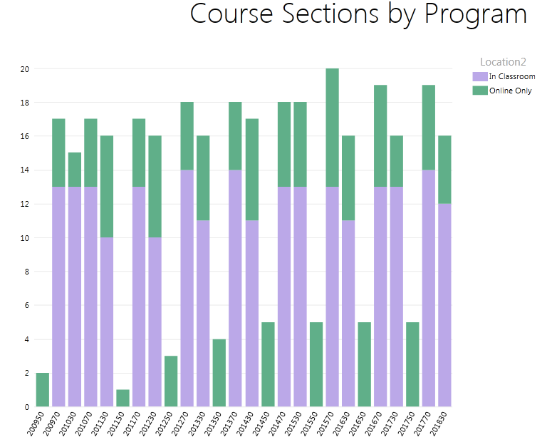
Fig. 1. Sections offered in Social Science, Summer 2009-Fall 2018.

- How does the current staffing structure positively and/or negatively affect the program?

The current staffing of full-time and associate-faculty instructors for the in-person and online courses adequately covers the demand for these offerings. In other words, the courses are being taught. In terms of effectiveness and stability, improvements can be made. Specifically, the lack of full-time faculty overseeing the psychology course offerings and anthropology programs has left these areas without direction or effective oversight. Similarly, there is no oversight of the psychology area other than evaluation of associate faculty. Given the traditional popularity of these courses and the anthropology degree, and in recognition of the dwindling/decrease in degree-seeking students in these areas, these areas, and the college itself, would benefit greatly from full-time faculty oversight. The increase in ISP students seeking the AA-T in Sociology also deserves greater attention and management, which currently falls somewhere in-between the ISP office and on-campus sociology faculty.

In the past, full-time instructors taught about two-thirds of all courses on-campus and online for the Social Science Program. There has been a shift towards more associate faculty teaching courses in the social sciences for a number of reasons. The creation of the sociology degrees means the college now offers a greater range of courses in the field. Dr. Desmond, the full time political science instructor, now splits her teaching load between political science and sociology and the courses she previously taught in political science and history are now taught by associate faculty as are courses in sociology, psychology, and anthropology. The lack of a full-time anthropology or psychology faculty means those areas must be covered by associate faculty. Also, the new bachelor’s program in agriculture means that the full-time history instructor must teach an upper division course specifically for that program. As a result, starting in Spring 2017, an associate faculty member is required to cover an extra section in history.
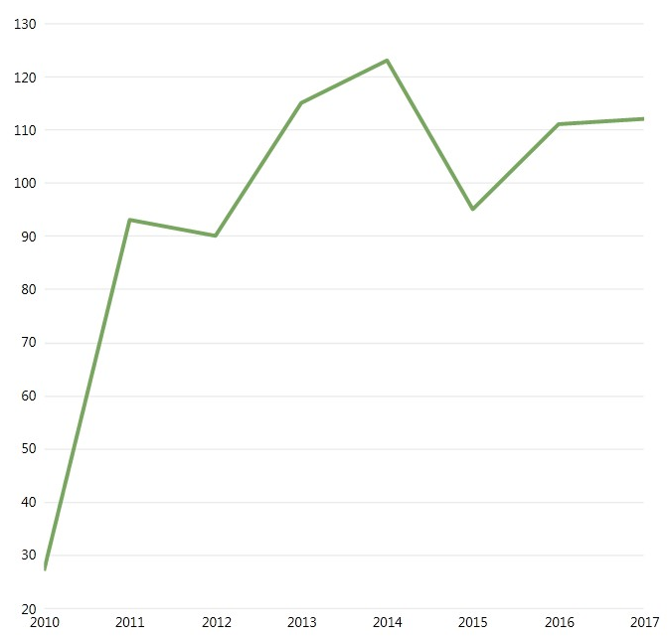
Fig. 2. Total of all degrees award in Social Science areas, 2010-2017.

It should be noted that more associate faculty have been required to cover courses in the Incarcerated Student Program. There is one associate faculty teaching the history courses required for the program; one associate faculty covers the required POL 101 course for students; one associate faculty covers the psychology courses, and one covers anthropology. ISP students have only one AA-T option and this is in sociology. As a result, there are currently over 75 Sociology AA-T degree seeking students in ISP, so two associate faculty, in addition to one full-time faculty are covering the required courses for the degree.

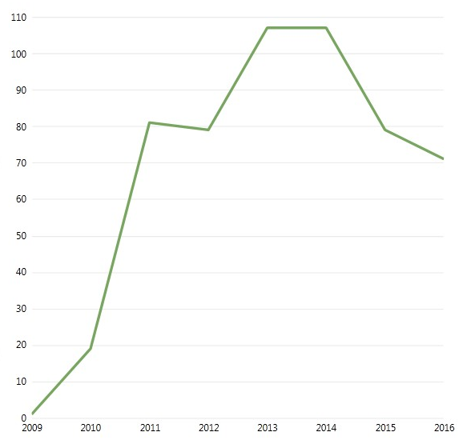
Fig. 3. Degrees in General Studies: Social Science awarded 2009-2016.

- What are the objectives and goals in staffing to make this program more effective?

The Social Science Program at FRC effectively utilizes SLOAC data, implements reasonable and relevant prerequisites, and adheres to transfer model curriculum (TMC) in the courses for degree offerings. Using and reflecting on all these, the Social Science program seeks to strengthen teaching effectiveness in all mediums including online, on-campus, and correspondence courses. In addition to the General Studies degree with an emphasis in Social and Behavioral Sciences, the Liberal Studies, with an emphasis in Sociology and Social Science, the program now includes approved AA-Transfer degrees in Anthropology, History, Political Science, and Sociology as well as local AA degrees.

The program’s goal is to ensure instructional effectiveness of all social science course offerings regardless of delivery mode. Given this goal, it is recommend that the college hire a full-time faculty in anthropology or psychology. Program offerings are still hampered by the lack of a full-time faculty member in anthropology and psychology, both of which could potentially be popular degrees, and courses in which are connected to other popular degree offerings.

The dramatic increase in Sociology AA-T degree seeking students in ISP also warrants greater commitment to this program such as assurance that the necessary courses be offered and staffing is consistent and sustained. One full-time faculty and one associate faculty on campus currently meet the course and scheduling needs for the four sociology and political science degrees. The sociology degree could better meet employment needs of social services in Plumas County if there were a full-time faculty vigorously managing and promoting the AA degree.

B. Curriculum, Instruction & Assessment

- Describe the educational path(s) that the program’s course offerings provide (basic skills, general education, certificate, associate degree, and/or transfer).

The Social Science Program encompasses a range of course offerings across disciplines and offers a number of discipline-specific and interdisciplinary degrees. The disciplines that comprise the Social Science Program include:

Anthropology
History
Political Science
Psychology
Sociology

The Social Science Program also offers extensive general education courses nearly all of which transfer to four-year universities and the vast majority of which satisfy GE social science requirements for FRC, the CSU Breadth, and the IGETC. Most students take the courses offered in the program in order to meet the GE requirements for graduation and transfer regardless of what degree they pursue. (The program offers no basic skills courses or certificates.)

The degrees currently offered include:

AA in General Studies, Social and Behavioral Sciences
AA in Liberal Arts, Sociology and Social Sciences

These are two of the most popular degrees at FRC because they are broad, contain classes that are commonly offered by the college, and transfer easily to many public and private universities in and out of state. In 2016 and 2017, there were 71 and 60 degrees awarded (respectively) in General Studies, and 2 and 8 in Liberal Arts. [Note that these degrees may be reported incorrectly to the State as the Chancellor’s office datamart shows no “Social Science” degrees awarded in 2016 but shows 77 awards in “Liberal Arts and Sciences, General-4901”. In 2014-15 the same degrees were coded as “Interdisciplinary Studies-49”.] During the 2016-17 AY, the college awarded 45 AA degrees in Liberal Arts: Social and Behavioral Sciences to students enrolled in the Incarcerated Student Program. [Data provided by ISP Director]
In 2017, degrees in the Social Sciences comprised more than 40% of all degrees awarded by the college, most of those were in General Studies. The General Studies degree is not considered a transferable degree within California nor does the Social Science Program view it as a valid base of coursework for future work in any of the social science disciplines. Instead, faculty encourage students to pursue more narrowly-focused degrees to better prepare them for upper division work at their transfer institution.

Associate of arts degrees are offered in additional social science disciplines including History, Political Science, and Sociology. Like the General Studies degree these degrees are not designed to prepare students for further work in the social sciences but rather to be a general, terminal AA degree for students who do not plan to attend a four-year university. With the charge and mission to transfer student in state, FRC has implemented a number of transfer degrees in the social sciences designed to fully prepare students for upper division work and to streamline transfer to four-year universities, particularly the State University of California. These degrees include:

AA-T, Anthropology
AA-T, History
AA-T, Political Science
AA-T, Sociology

Additionally, FRC possesses substantial numbers of courses that fit the TMC for psychology, but the college does not currently offer a degree in this area.

As written in the previous CPR, the college does not offer a course in social science quantitative methodology which would better fit the curriculum for these degree seeking students who will be expected to possess more than a basic understanding of statistics as they enter their upper division course work. Curriculum for the degrees are only adequately met with the courses currently offered.

The General Studies and Liberal Arts degrees continue to be favored by student athletes, most of whom transfer to out of state institutions. This will continue to be the case in the foreseeable future, and as previously written, the overly-general interdisciplinary nature of these two degrees makes effective assessment of program-level SLOs profoundly problematic.

- Describe any changes in the following since the last program review. Explain the reasons for those changes, and their impact on the program.
  - Curriculum (including articulation and course scheduling)
  - Instructional methodology (i.e., distance education)
  - Assessment

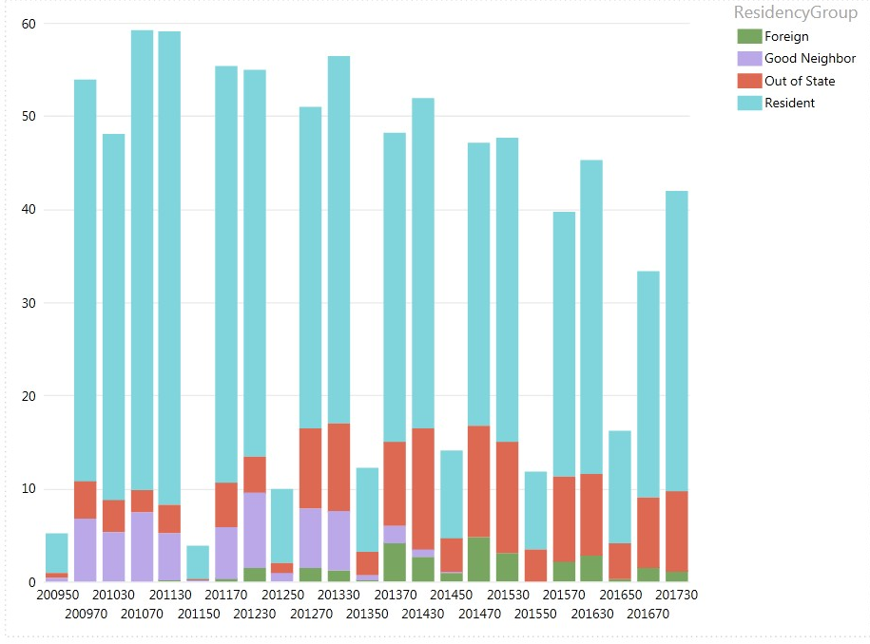
Fig. 4. Total FTES produced by social science courses Summer 2009 to Spring 2017.

Total enrollment in classes in the social sciences has declined somewhat since 2010 as it has in all classes offered to FRC. (See Graphs 3 and 4).

With the addition of the transfer degrees in sociology and political science, and students every semester who declare these majors, the courses necessary for degree completion have been offered regularly. While class sizes in the POL 101 and SOC 102 courses remain steady and high, the other courses required for these degrees are smaller. However, the program is committed to ensuring two- year completion for those degree seeking students. Sociology 100 was offered on campus in 2017 for the first time in over nine years and enrollment was greater than anticipated. The course fulfills AA-T degree requirements, but also can be taken to complete GE patterns as an alternative to SOC 102. Also, the required SOC 150 courses is now regularly offered on campus and taught by an associate faculty member. This has exposed students a greater scope of perspectives necessary in the field.
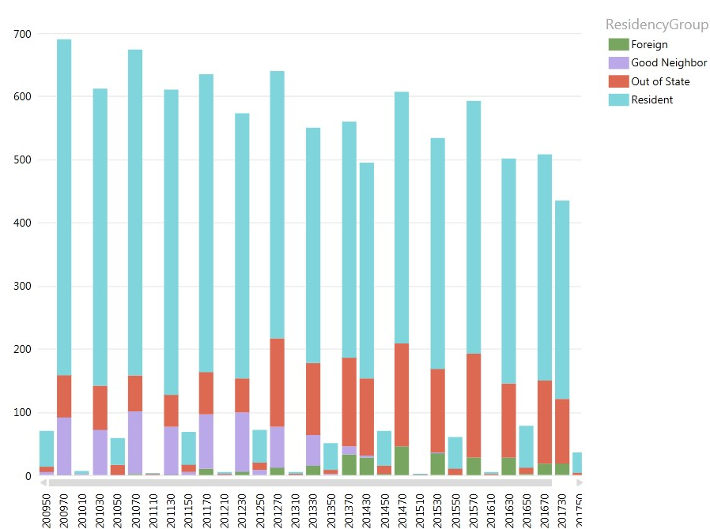
Fig. 5. Total FTES produced by non-ISP courses at Feather River College.

Sociology 100 and SOC/POL 160 were added to the ISP curriculum, which was necessary for ISP students hoping to complete the AA-T. Two associate faculty were hired to create and deliver these correspondence courses. It is hoped that the SOC 150 course will be created and delivered for ISP in 2017-2018, the final piece for degree completion.

Curriculum in History has been significantly modified in order to meet articulation requirements or to meet new degree requirements. The World History survey was previously designed as a three semester sequence to meet degree requirements for CSU Chico, but due to demands from the C-ID program the three courses had to be squeezed into two semesters. Similarly, new C-ID requirements to have both US History survey courses cover the period of Reconstruction as well as entirely new SLOs; after numerous revisions, the courses were approved for articulation. A new, upper division course in the history of the American West was created for the new Agriculture baccalaureate degree and was offered during the Spring 2017 semester. The college plans on offering this course each Spring semester.

Online courses in the social sciences have been consistently offered in the regular and summer semesters. During the 2016-17 academic year, all online course and those on-campus courses that used resources online were moved to the college’s new Canvas learning system (frc.instucture.com). This move was accomplished with few problems, and all users, particularly students, appear to have adapted to the new system well.

All degrees and courses in the program have established outcomes. The full-time faculty in sociology and political science works closely with associate faculty to assess student learning. This collaboration is structured around the course SLOs which “feed into” the program level SLOs.

- What has been achieved in program- and course-level Student Learning Outcomes (SLO) Assessment Cycle since the last program review? Describe the successes or difficulties the program has faced in SLO assessment.

All courses in the social sciences are consistently assessed.

Accomplishment of degree level SLOs for the General Studies and Liberal Arts degrees remains difficult to assess on an aggregate level. According to the National Clearing House, the students who graduated from FRC with degrees in the social sciences during 2009-2014 totaled 1259 students 30.3% of whom transferred to a 4-year university. 55% of those social science students who enrolled at a 4-year university graduated so far, as of 2017. [National Clearinghouse data for 2009-2014 cohorts]

Cohort of | Obtained AA in General Studies: Behavioral & Social Sciences from FRC | Enrolled in 4-yr institution | Transfer rate
2014-15 | 60 | 38 | 63.3%
2015-16 | 66 | 51 | 77.3%
2016-17 | 57 | 31 | 54.4%
Total 3 cohorts | 183 | 120 | 65.6%
Fig. 6. General Studies: B&SS graduates transfer rates to 4-year universities.

Looking specifically at the NCH data on the population of students who graduated win an AA in General Studies: Behavioral & Social Sciences (by far the single most common degree awarded) we find that about two-thirds of all graduates are able to enroll in a 4-year institution. Although we do not know what level their universities received these transfer students at (e.g., sophomores or juniors), considering the degree is meant to be terminal and not for transfer this could be considered a rather high rate of transfer. However, of these 183 students nearly 20% (n=36) enrolled at another community college after FRC which suggests that some students had to complete courses elsewhere in order to meet entrance requirements at the university. Nevertheless, significant numbers of General Education students were able to transfer to CSUs and to UNR. [NCH data, 2017]

The ISP program has also had success in the social sciences. During the 2016-17 AY, the college awarded 45 AA degrees in Liberal Arts: Social and Behavioral Sciences to students enrolled in the Incarcerated Student Program. [Data provided by ISP Director]

With assistance from Student Equity, some curriculum revisions were made in 2016-17 POL and SOC courses. This was based on assessment data that revealed a weakness in student learning around understanding political ideology (POL), the significance of citizen participation (SLO in POL courses, aligned to CWSLO), and in sociology, difficulty applying sociological perspectives for analyzing contemporary social issues. Assessment findings also showed less success by racial minorities in these courses. It was determined that this may be due to the use of assessment mechanisms limited to in-class essay writing. In summer 2016, all lectures for online SOC and POL courses were recorded. Also, a project requirement was incorporated into SOC 102 and POL 101 in fall 2016. These revisions led to some noticeable success (based on project and course grades) in POL 101. However, the online course analytics show that only few students accessed the recorded lectures.

Faculty in the program are experimenting with newly-available free, electronic textbooks to encourage reading, and to meet the California legislature’s recommendation on textbook affordability. Faculty have seen that many students do not purchase textbooks in order to save money, and then find themselves struggling to succeed in classes. Free SOC 102 and HIST 108 textbooks were used in the summer 2017 online courses, and such textbooks will be used for the HIST 108, 110, and 111 and POL 101 classes during the fall semester. The results of these changes will be addressed in the forthcoming SLOAC.

- What are the program’s weaknesses and strengths in the area of curriculum and instruction?

Strengths:
- Course offerings meet transfer and degree requirements.
- Courses in history, political science, and sociology are scheduled to ensure two-year degree completion.
- Good communication among program full-time faculty, and most associate faculty.
- Student interest in the program and degree offerings has increased, evident in consistent enrollments and degree declaration.
- Students are graduating with AA-Ts in history, political science, or sociology since the inception of these degrees.
- Students are being exposed to world views and perspectives; courses in the social sciences address many of the college-wide SLOs and FRC mission.
- An internship opportunity with the Board of Supervisors has been created for a political science student.

Weaknesses:
- There is a lack of a diversity of perspectives due to limited number of full-time faculty in the social sciences.
- The anthropology degree is difficult to offer, and most courses are only available online. As a result, a potentially popular degree is not meeting its potential or student interest.
- Course offerings in psychology have been limited exclusively to PSY 102: Introductory Psychology. What is a discipline popular with students is limited to a single course due to the lack of faculty.
- Inability to offer a course specifically in social science quantitative methodology which is supposed to be a part of the AA-T degrees in the social sciences such as Sociology.
- Most students are advised to complete, or at least enroll in, ENG 101 prior to enrolling in most social science courses, but this remains a problem as students without college-level reading and writing skills continue to enroll in these courses. The result is often that they are not successful which increases their student debt, time to degree completion, and anxieties about learning.

- What are the objectives and goals in curriculum and instruction to make this program more effective?

- Continue to improve webpages for the various disciplines and degrees with the intent to improve access, outreach and recruitment, particularly for history.
- Create relationship with CSU, Chico anthropology, history, political science, and sociology programs. Obtain a better understanding of skill and curriculum expectations, beyond the more general TMCs.
- Establish internship opportunities with local entities such as with Plumas County social services for an AA or AA-T sociology-degree seeking student and an internship at the Plumas County Museum for a history-degree seeking student.
- Continue emphasizing involvement in community and importance of citizen action at the local, regional, national, and global levels.
- Re-emphasize the importance of national institutions, global issues, and global citizenship especially in a time of increased nationalism and isolationism.
- Hire full-time faculty in anthropology, sociology, and psychology.

C. Physical Resources

- How is the program affected by the size, type and quality of available:
  - physical space and facilities
  - information technology
  - library holdings
  - instructional equipment and supplies

Physical space and facilities are satisfactory. Smart podiums, classroom projection and audio equipment are available in all classrooms, but does not function consistently and in some cases updating. The Library media collection is transitioning to Blu-ray while only one or two classrooms are equipped with Blu-ray players and no computers on campus are so equipped.
Classrooms are not always clean (windows, spider webs, dusting, etc.), and temperature fluctuations are not conducive to learning (AV 239 is often cold while the gallery and 608 are sweltering).

Information technology is limited by the internet bandwidth available on campus. Improvements to speed are always appreciated. Improved wireless access and speed is also necessary. Using smartphones for polling or respondus activities is not possible as most students still have trouble connecting FRC’s WIFI and most cell phones have no connections on campus despite the installation of cell-service extenders. Some podium computers are approaching obsolescence. Lastly, smart whiteboards have been purchased for classrooms, but have yet to be installed outside of a single classroom in the Media Center.

Library holdings are generally good and continue to improve. The Librarian continues to expand and improve electronic holdings and databases in collaboration with program faculty to include up-to-date printed works and electronic versions of relevant professional journals as current electronic DB tend to have only basic primary sources and encyclopedia-type materials. Book and media requests are met in a timely manner, and efforts to ensure access to closed captioning are consistent. But library video holdings are increasingly tipping towards the Blu-Ray format and classroom podium players or PCs should be updated accordingly.

- Have there been significant changes in the program’s facilities, technical infrastructure, or other resources since the last review?
See above.

- What are the program’s projected needs in facilities, technology, or other resources, and how are these needs related to program goals?

See above.

D. Student Retention and Success

- Describe any significant trends within the student demographics of the program.

Data from Fall 2012 to Spring 2017 (duplicated headcount including ISP and contract ed. students) indicate that students enrolled in social science classes averaged of 245 FTES annually with a total of 980 FTES for the period. Excluding ISP and CE (that is, only courses taught through the main campus and online), the Program generated an average 105.9 FTES and a 4-year total of 424 FTES. Since many of the courses offered by the Department are General Education courses (including some required for transfer to four-year universities), FTE generation by the on-campus and online sections has tended to be in a slow decline from 118 in the 2013-14 year to 93.11 in 2016-17.

There have been no significant changes in the demographics of students enrolled in the courses offered by the program. Since many of the social sciences are transferable general education courses, it is not surprising that courses offered in the program draw students reflective of the gender distribution at the college. Females comprised 56% of the total number of students enrolled in social science courses for the 2015-16 AY compared to 54% of the total college population being female. Social science courses tend to attract a more ethnically diverse population in comparison to the overall college student population with an average of 37.5% of students enrolled in social science classes during the 2015-16 AY identified as non-white enrolled in social science classes [unduplicated headcount FRC data], while the college’s average has been about 33.4% (and in striking contrast to Plumas County’s 2010 census of 11% nonwhite). This is probably due in part, again, to the GE characteristics of the courses which would attract full-time students who include many students from outside of Plumas County, but may also reflect the nature of the disciplines that explore alternative perspectives and study systems of power and ideas of justice and democracy.

- What are the program’s strengths or weaknesses in the area of student retention and success?

Overall, the Social Science program’s retention and success rates nearly match the statewide averages. In Social Science statewide, the success rate is 66.4% (66.46% for in-classroom instruction, and 61.4% for DE modes) while the overall retention rate is 85.47%. [Source: Chancellor’s Office Datamart] Social Science classes at FRC during the Spring 2016 AY (the most recent semester for which there is somewhat complete data) had an overall success rate of 68.3% [Source: Chancellor’s Office Datamart] for non-ISP classes (both on-campus and DE). Unfortunately, due to chronic coding differences in the Chancellor’s Datamart there is no way to provide a breakdown between on-campus and DE classes. (The Spring 2016 Datamart shows a final enrollment of just 15 in DE classes when there were actually 113. Other semesters show very similar errors.)

- What objectives and goals are needed to better ensure student retention and success?

Success rates in social science courses are comfortably close to the statewide averages, but as usual, exceeding the average is desirable. There remain a number of issues that need to be addressed.

For some time program faculty have discussed implementing prerequisites for some, perhaps many, of its courses. Advisories are listed for History 108 and History 110 recommending the successful completion of English 010 prior to enrollment, but students sometimes ignore those requirements and college advisors perhaps do not strongly warn students about this advisory. There has been some improvement which has resulted in a decrease of students who were entirely unprepared for college-level work, but even so, many students are unprepared for the level of reading and writing that is expected in many of the Program’s courses. Indeed, some unprepared students simply demonstrate a complete lack of awareness of the academic expectations in such courses, and, in most cases, no amount of warning or cajoling can affect their enrollment in a class which they inevitably fail.

In the previous CPR, FRC’s Institutional Researcher did an initial analysis of success rates in History 108 and the English 010 advisory. He found that the success rate for History 108 overall in Fall 2012 was 58%, however, for students who had not yet successfully passed English 010, the success rate was 25%. His analysis of this one course in one semester strongly suggested that students needed reading and writing skills equivalent to that expected in English 101, and thus should have a prerequisite of English 010. However, prerequisites requiring the successful completion of English 010 or the equivalent prior to enrollment in a Program course may be less than effective given the current (AY 2017-18) movement towards “multiple measures”. The Program should revisit the question of prerequisites in the next scheduled CPR to see what the impact of the new English matriculation policies will be in the coming years.

Previous CPRs have expressed reservations about the academic quality of some classes offered in ISP or by AF online, but substantial progress has been made in this area. All courses offered via ISP have received at least one round of evaluation by full-time faculty and courses have been revised or otherwise improved in their academic rigor. Furthermore, most courses in the Social Sciences show similarities in grade distributions. In the past in some classes 40% or more of students were awarded grades in the “A” range which suggested a lack of rigor. A survey of grade distribution for classes offered in AY 2015-16 shows relatively similar ranges across classes with between 17% and 25% of grades being in the “A” range. This implies that the work assigned by instructors and the assessments of submitted student work is of a similar quality across the disciplines in the program. [FRC’s APRData & CCC’s Datamart]

Goals regarding curriculum and instruction as far as student retention and success:
- Continue monitoring student preparedness with the intent of designing and implementing relevant and applicable prerequisites including possible changes to course content in CORs.
- Maintain collaboration among program faculty across the disciplines to ensure quality of learning and rigor; particularly in psychology and anthropology where there is not a full-time faculty overseeing these degrees.
- Continue promoting courses and degrees on webpages.
- Promote job opportunities and careers in the fields.

E. Community Service

If program faculty and staff are tasked with community service, which can include outreach, consulting or technical assistance, service-based instruction, or economic development, please respond to the following.

- In what types of community outreach does the program engage, and how is the program’s academic and professional expertise extended to the local communities?

- An internship with the Plumas County Board of Supervisors has been created for a political science AA-T degree seeking student.

F. Advisory Committees

If there is a program advisory committee, list the names and titles of members, and the meeting dates since the last program review. Describe any advisory committee involvement in this program review.

N/A

G. Appendices

N/A

The Program Review Process
Program review ensures that the college’s academic programs are effective and responsive to students and the local community within the limitations of available resources. The review process includes the systematic collection, analysis and interpretation of relevant data, an assessment of progress made in achieving student learning outcomes, the fulfillment of program needs, and the accomplishment of program objectives and goals.

Academic program review is an integral part of educational planning, supports the Enrollment Management Plan, and enables the college to meet the accreditation standards of the Accreditation Commission for Community and Junior College (ACCJC).

The major objective of program review at Feather River College is to guide the development of the Education Plan. Essential items within program reviews include the following:
- Collect and analyze accurate and complete data on key performance indicators, student learning outcomes, program activities, and accomplishments.
- Ascertain and document program weaknesses and strengths.
- Develop program objectives and goals.
- Justify program budget requests.
- Comply with Federal and State law, Title 5, Student Equity, VTEA, matriculation (including prerequisite and co-requisite standards), ADA (American with Disabilities Act), and other legal or certification requirements.

This template is an adaptation of the Instructional Program Review template designed by Saddleback College.

